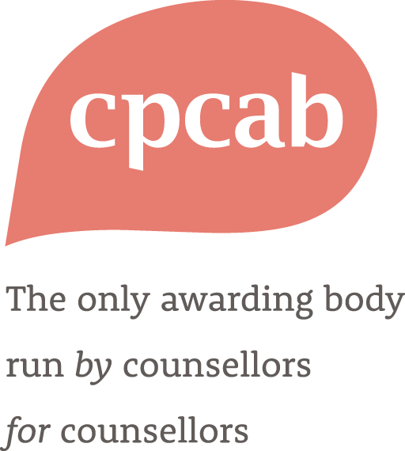

BACP Approved Practitioner Qualification - CPCAB Level 4 Diploma in Therapeutic Counselling

Centre Application and Agreement

Counselling & Psychotherapy Central Awarding Body (CPCAB)

P.O. Box 1768

Glastonbury

Somerset

BA6 8YP

Tel. 01458 850 350

Website: [www.cpcab.co.uk](http://www.cpcab.co.uk)

Email: contact@cpcab.co.uk

BACP Approved Practitioner Qualification - CPCAB Level 4 Diploma in Therapeutic Counselling

CPCAB and BACP are engaged in a qualification partnership between the two organisations designed to support qualification standards and enhance the pathway to becoming a registered BACP counsellor.

**Context**

The BACP Approved Practitioner Qualification (APQ) scheme differs from BACP’s existing Accredited Course scheme in that the agreement is at qualification level with the awarding organisation, not with the individual course provider. For BACP, this scheme represents a way of working with qualification providers, rather than placing the onus upon individual training providers to apply for BACP course accreditation at centre level.

To this end CPCAB have worked with BACP to map the current CPCAB Level 4 Diploma in Therapeutic Counselling (TC-L4) to the requirements for BACP Qualification Approval. This ensures that it meets the high standards of both organisations in terms of content, curriculum, delivery, assessment and practice requirements. The qualification has also been mapped to the relevant BACP professional standards and competencies including the BACP Online and Phone Therapy Competence Framework and the BACP Ethical Framework for the Counselling Professions.

**Overview of the APQ Offer**

Candidates who successfully complete an approved TC-L4 diploma will have the Certificate of Proficiency facilitated directly for them by their training provider and will be able to apply directly for Individual Registration with BACP. Candidates can also be reassured that their qualification has already been approved by BACP.

The TC-L4 qualification, including new guidance for online and telephone counselling, is unchanged and candidates can expect to receive the same robust TC-L4 qualification they always have, with additional BACP resources available and a smooth transition to registration with BACP. They will also receive certification that includes both a CPCAB and BACP logo together with confirmation that they have completed a qualification that meets the standards of the BACP Approved Practitioner Qualification scheme.

The BACP approved qualification is offered to all centres who have TC-L4 approval. Centres who do not wish to participate or who have aligned their course delivery with an alternative professional association or register can continue to deliver the standard TC-L4 as normal.

Centres wishing to adopt the BACP Approved Practitioner Qualification can do so by fulfilling some conditional requirements that ensure they are delivering the qualification in a way that fully endorses the BACP Ethical Framework for the Counselling Professions, the BACP Online and Phone Therapy Competence Framework and models best practice for BACP student members. These requirements are detailed in the centre agreement below.

We hope that this is adopted as a valuable opportunity for centres who wish to provide their students with a straightforward route to BACP registration.

**Meeting BACP and CPCAB Requirements**

CPCAB is required to ensure that all centres have the necessary resources to deliver CPCAB qualifications according to the published requirements. These requirements are primarily about protecting the interests of candidates. You must therefore confirm that your centre can meet all the following requirements before being approved to deliver the BACP Approved Practitioner Qualification - CPCAB Level 4 Diploma in Therapeutic Counselling.

When you are sure you can meet these requirements, please ‘x’ the boxes on the right and sign the declaration at the end. It is the centre’s responsibility to provide documentary evidence if requested.

Once this document is signed and approved it constitutes a written and enforceable agreement between your centre and CPCAB (Ofqual, CCEA and Qualifications Wales- General Condition C2). Centres that fail to meet these requirements may be subject to the CPCAB [Sanctions policy](https://www.cpcab.co.uk/public_docs/sanctions-policy). (See also CPCAB policies on [Malpractice and Maladministration](https://www.cpcab.co.uk/public_docs/malpractice_maladministration), [Complaints](https://www.cpcab.co.uk/public_docs/complaints_policy) and [Whistleblowing](https://www.cpcab.co.uk/public_docs/whistleblowing_policy) on the CPCAB website).

Centre Application and Agreement

|  |
| --- |
| **Our Centre name:** Type centre name here  **Our Centre number:** Type centre number here  **wish to deliver the BACP Approved Practitioner Qualification - CPCAB Level 4 Diploma in Therapeutic Counselling. To do so we understand we must confirm the following requirements are in place for our centre, and that they will remain in place for the duration of the qualification.** |

|  |  |
| --- | --- |
| The Centre has received CPCAB approval to run the standard Level 4 Diploma in Therapeutic Counselling. |  |
| The Centre has received CPCAB approval for online delivery |  |
| The Centre will deliver the qualification through blended methods (face-to-face and online) |  |
| The Centre will support candidates to engage in a blended placement (including in-person and online / telephone client hours) |  |
| The Centre will deliver the TC-L4 so that it meets the minimum requirements of the qualification, including a supervised placement of a minimum 100 hours, and minimum of 10 hours personal therapy. |  |
| The Centre will participate in all CPCAB quality assurance processes, including External Verification and Standardisation. |  |
| The Centre understands that there is no initial fee for BACP approval, but that an additional fee of £25 per candidate is payable in year 1 upon registration. |  |
| The Centre will provide CPCAB with candidates BACP student membership numbers in year 2 upon registration. |  |
| The Centre will update their [Privacy Notice](https://www.cpcab.co.uk/public_docs/privacy_notice_template_guidance?search=Privacy%20Notice) to candidates to include the sharing of candidate and student membership numbers between CPCAB and BACP |  |
| All tutors involved in the delivery and assessment of the TC-L4 have been approved by CPCAB as appropriate to deliver this qualification (minimum of 2 tutors per course delivery) |  |
| All tutors are members of BACP, agree to work within the current BACP Ethical Framework for the Counselling Professions (Ethical Framework) and understand that they are subject to the BACP complaints procedure. |  |
| All candidates registered on the approved qualification will become BACP student members for the duration of the qualification, and agree to work within the current BACP Ethical Framework for the Counselling Professions (Ethical Framework) and understand that they are subject to the BACP complaints procedure. |  |
| All candidates will undertake sufficient and appropriate counselling supervision from a suitably qualified counselling supervisor to meet BACP supervision recommendations for trainee counsellors. |  |
| The Centre will provide resources required to facilitate candidates undertaking the BACP Certificate of Proficiency after candidates have completed a minimum of 70 supervised client hours in a placement. |  |
| The Centre agree to provide candidates with the Centres policy regarding re-sits of the Certificate of Proficiency. |  |
| The Centre agree to meet CPCAB and BACP requirements regarding certification of candidates. |  |

**Declaration**

I confirm that all the information given above is accurate:

I confirm that the centre will take all reasonable steps to comply with these requirements for centre recognition and understand that CPCAB may be obliged to impose reasonable and appropriate sanctions if these requirements are not met:

**Signed:** (on behalf of the centre)



**Name:**

Please print your name here

**Position:**

Type your position here

**Date:** Click or tap to enter a date.

CPCAB reserves the right to refuse recognition to a centre if the application gives rise to ethical or professional concerns, or if a centre fails to provide appropriate supporting evidence or fails to meet the application criteria. Any such decisions will be given in writing.

**Signed:** (on behalf of CPCAB)



**Name:**

Please print your name here

**Position:**

Type your position here

**Date:** Click or tap to enter a date.